***Displaying Signals Information at UI***

***Work Flow***

**DAL**

**UI**

**BLL**

**Data Base**

***Project Folder Architecture***

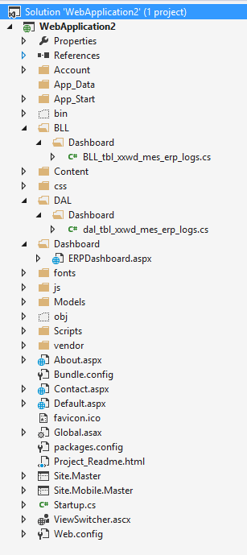

***Dash Board UI Signal Data for Every 30 minutes Work Flow.***

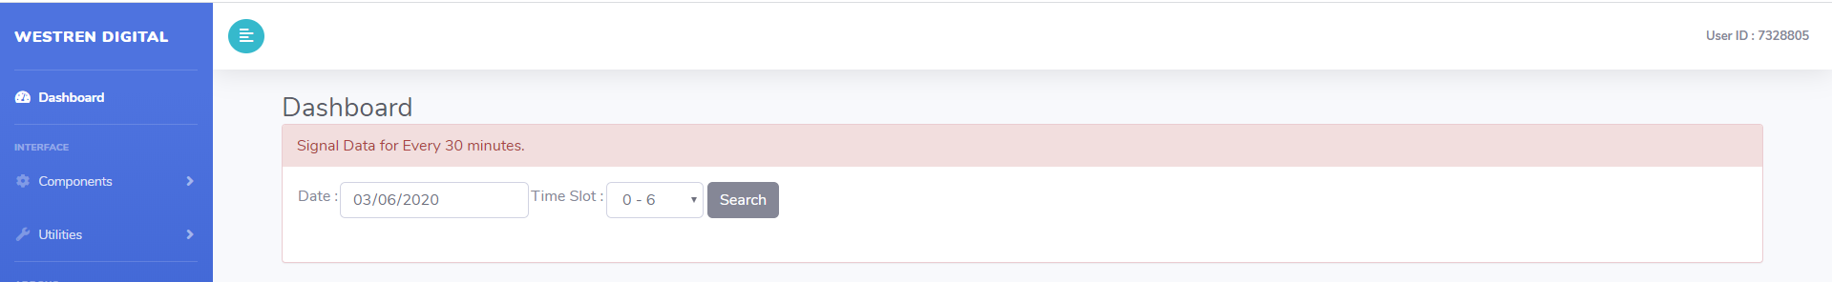

***C# Code Explanation***

***Search Button Click Event:***

**Passing the Date, Time Slot & Time Duration to BLL (Method), get the Data and display in Table.**

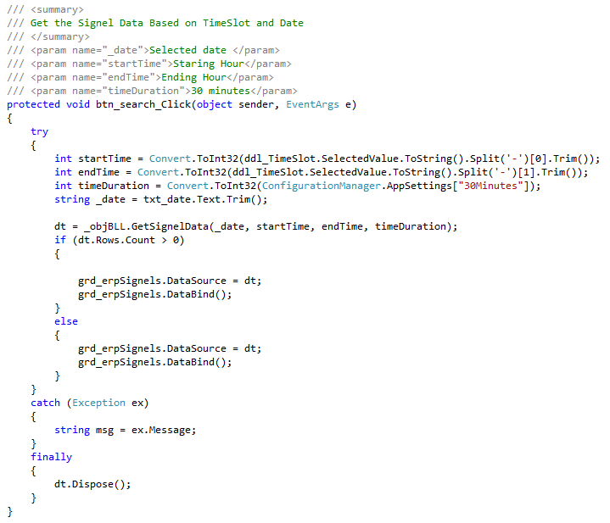

***Transaction Type Status (Color Changing):***

**Based on the grd_erpSignels_RowDataBound()**, (**Transaction Type Status) manipulate the Colors (1-Yellow, 3-Red)**

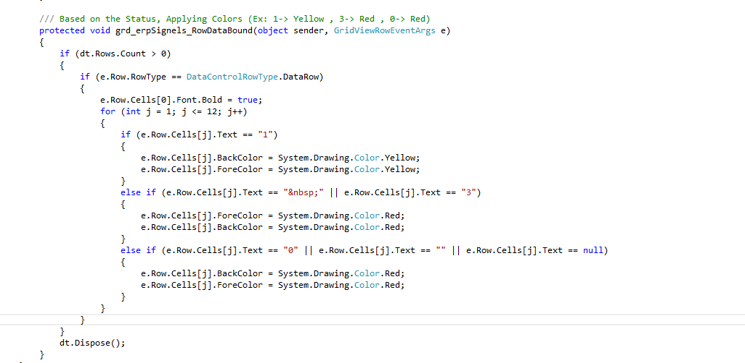

***BLL Class .cs***

1. **Based on the GetSignelData(), calling the DAL .cs file for Call the Data.**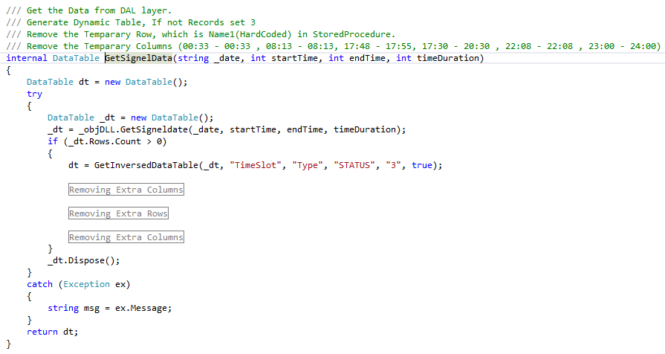
2. **Based on the GetInversedDataTable(), manipulate the Data to Dateable.**

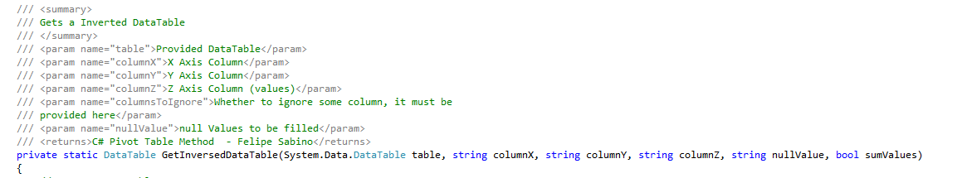

***DAL Class .cs***

1. **Connection String Calling from Web.Config file.**



1. **Based on the GetSignelData (), call the Database and store the data in Data table.**

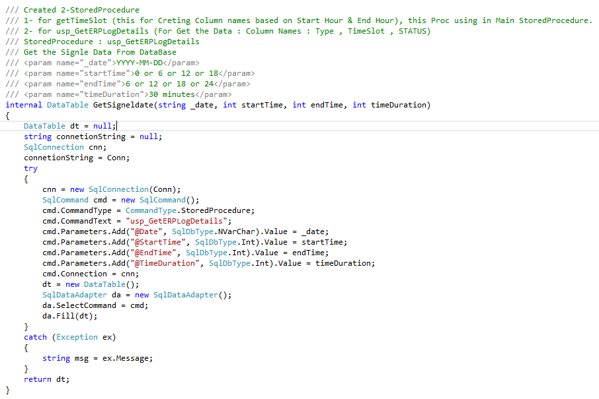

***Step- 1: Date (03/06/2020) & Time Slot (0 - 6)***

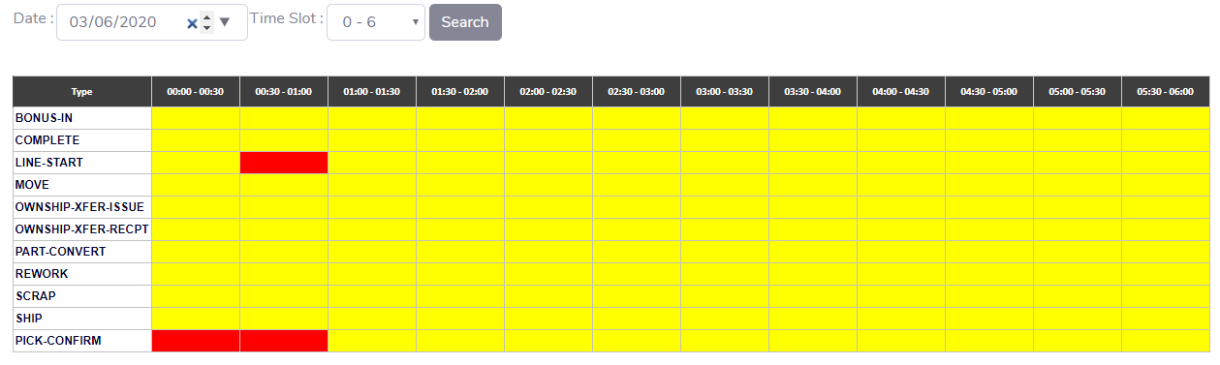

***Step- 2: Date (03/06/2020) & Time Slot (6 - 12)***

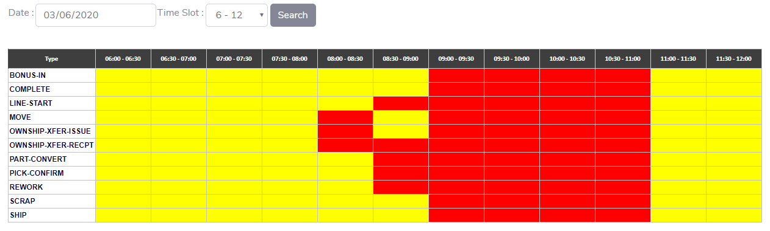

***Step- 3: Date (03/06/2020) & Time Slot (12 - 18)***

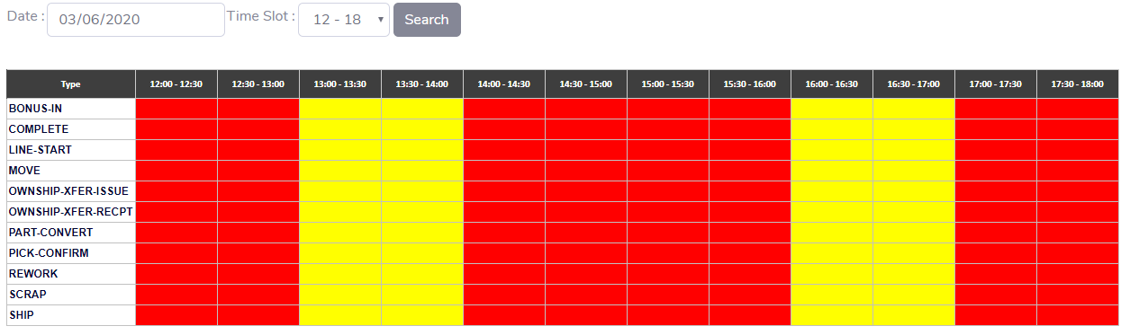

***Step- 4: Date (03/06/2020) & Time Slot (18 – 24)***

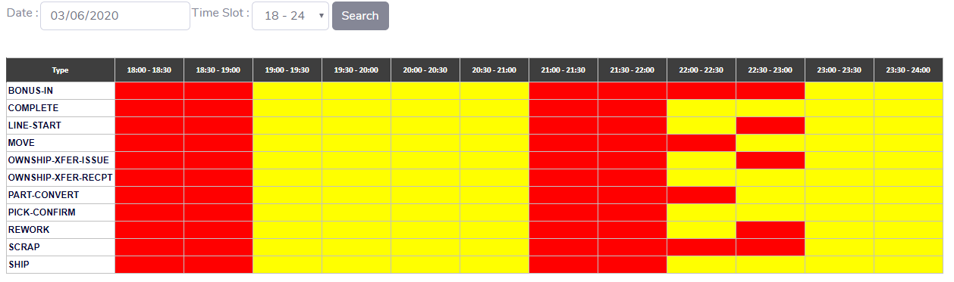

***Step- 5: Date (03/03/2020) & Time Slot (18 – 24)***

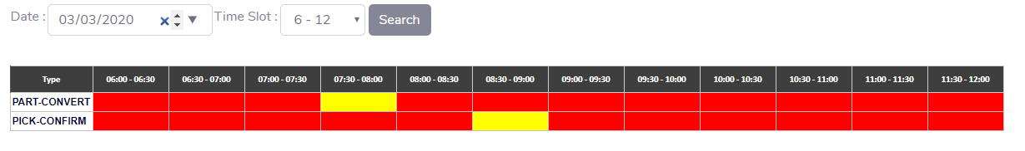

***NOTE:*** **In this Time Slot (18 - 24), I found only 2-Records.**

***Step- 6: Date (03/03/2020) & Time Slot (12 –18)***

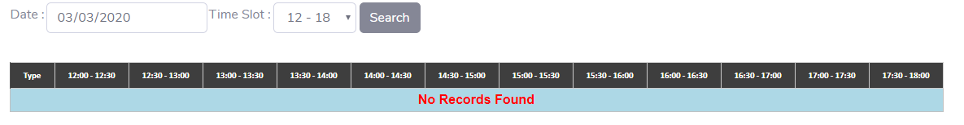

***NOTE:*** **In this Time Slot (12 - 18), No Records inserted in DB. So showing No Records Found Message.**

***Step- 6: Date (02/28/2020) & Time Slot (18 –24)***

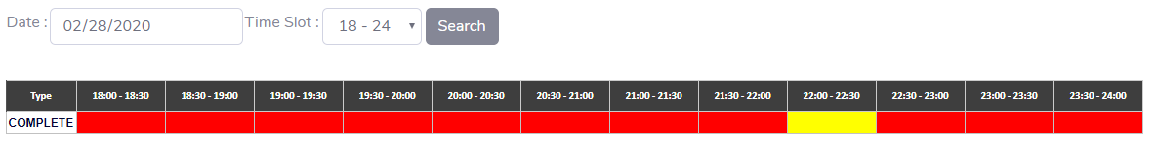

***NOTE:*** **In this Time Slot (18 - 24) & Date (02/28/2020), Only One Record inserted at 22:00 to 22:30 in DB.**

***Data Base***

1. **Two New Stored Procedures**

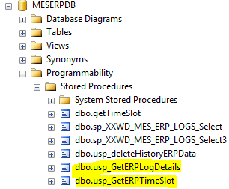

1. **Purpose of 2nd Stored Procedures, creating the Header Names based on the Time Slot.**

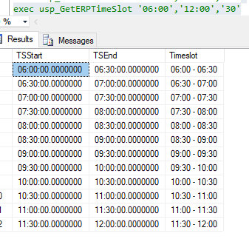

1. **Generating the Data based on 1st Stored Procedure.**

